COLD ASHBY VILLAGE (memorial) HALL
Main Street, Cold Ashby NN6 6EL
Charity number 1024816
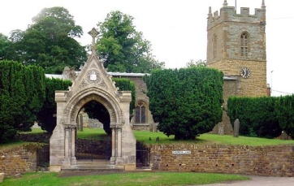
Annual General Meeting

Wednesday 16th June at 7 p.m. Sports Pavilion

Minutes

1.Rod Bailey took the chair,
2. Attendance: R Bailey, G Jones, C Sellers, R Miller. Other members of the public attended for some of the meeting.
3. Apologies: no apologies received
4. Minutes of the 2018-19 AGM: taken as read.
5. Matters arising from the minutes: none
6. Chairman's report: the chairman highlighted the lack of ideas for the development of the hall and asked that members be prepared to put forward their thoughts for the future, if there was to be a future for the village hall. He pointed out the need to restart the lottery but this would be difficult in the absence of volunteers.
7. secretary/treasurer's report: the treasurer presented figures which showed little income for the previous months under lockdown but also only income from bowls, luncheon club and elections, plus lottery income in the months before lockdown. There were some large bills in the offing and without income the hall would survive for around 3 years.
8. Adoption of accounts for year 2019/2020. The accounts were adopted unaudited.
9. To elect a committee in accordance with the trust deed to act until the next annual general meeting. A) Four elected members; the secretary was the only member elected in this group. B) plus one each to represent and elected by the Bowls Club, The Parish Council (R Bailey) and the Parochial Church Council (R Miller). Others as appropriate. (C Sellers, luncheon Club)
11. Programme of meetings until the November 21 AGM: third Tuesday of each month. Next meeting 20th July. Then 17th August, 21 September, 19th October 16th Nov (AGM)
12. To elect officers of the committee: the chairman agreed to serve, if elected, for a further year beyond the next AGM. Likewise the sec/treasurer.

G Jones, Secretary May 2021

NB: The AGM was postponed in November 2020 and this was the first opportunity to get together again. The Sports {Pavilion) has been chosen as a venue because it is a more Covid secure environment at the moment and because the annual village assembly is scheduled for the same evening at 7.30, or at whatever time the above AGM finishes if that is later than 7.30. The future of the Village Hall is an item on the assembly agenda.

Overleaf are the accounts for the full year 2019-2020 and the accounts for this year.

I hope to see you on the 16th and apologise that this meeting was called without the consultation we should have preferred.

